TuraQuant KOL Platform · Assessments Module
AI usage and data protection in KOL assessments
This brief sets out exactly where the assessments module uses artificial intelligence, what information is sent outside the platform when it does, and the controls that govern access to healthcare-professional data throughout.
Module  Assessments | Scope  KOL scoring & CV intake | Prepared  19 August 2026 | Classification  Client confidential

1 In summary
The assessments module uses AI in four places, all of them concerned with reading a healthcare professional's CV and turning it into structured, scored data. Every one of those calls is routed through a single, centrally configured service, so there is exactly one place in the platform where information is handed to a language model.
Alongside AI, the module draws on five public research sources to corroborate a profile. These are not AI services, but they do involve outbound queries, so they are documented here on the same footing.
AI provider credentials are held server-side only and are never exposed to the browser or to end users. The model never has the final word on a score: every response is validated, every score is capped at its configured maximum, and each parameter can be reviewed and signed off by a named human assessor.
2 What crosses the platform boundary
Everything to the left of the dashed line stays on TuraQuant infrastructure. The labelled arrows are the only paths on which assessment data leaves it.
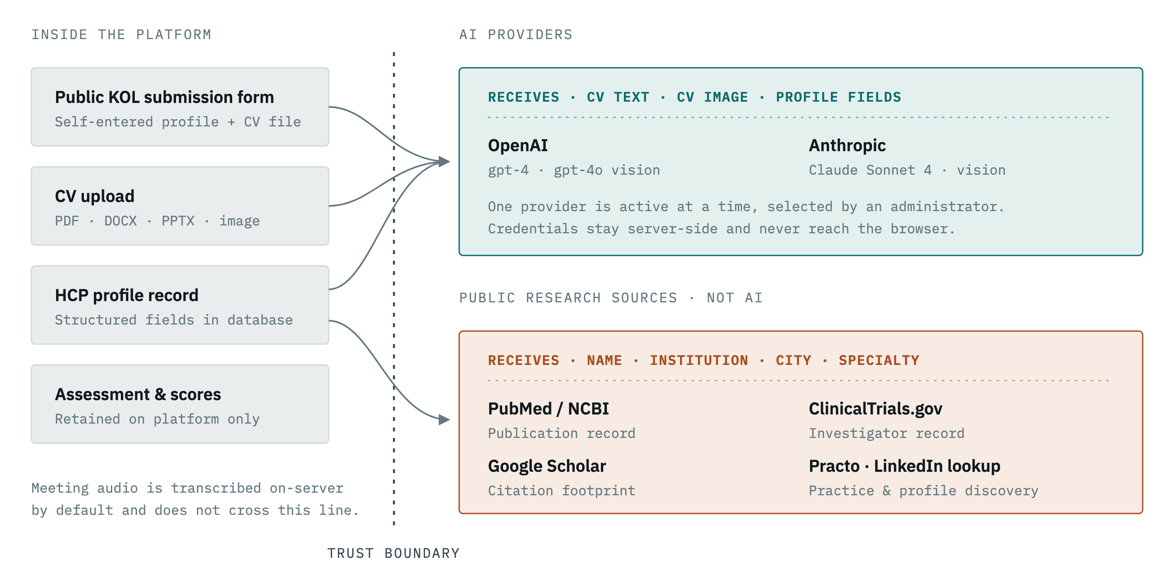
Figure 1 Data flow across the platform boundary. Assessment results, per-parameter justifications and the audit trail are written back to the platform database and are not sent anywhere outside it.
The same paths, stated row by row:
Stays on the platform | Crosses the boundary | Goes to
Assessment records, scores and tiers | Nothing — retained on platform only | —
Per-parameter justifications and audit trail | Nothing — retained on platform only | —
Uploaded CV files | CV text, and the image itself where the CV is a scan | Active AI provider
HCP profile record | Up to 14 profile fields, including medical registration number | Active AI provider
HCP identifying fields | Name, institution, city, specialty | Public research sources
Meeting audio | Nothing by default — transcribed on-server | —

Active AI provider — one at a time, selected by an administrator
Provider | Models in use | Used for
OpenAI | gpt-4, gpt-4o (vision) | CV field extraction, parameter scoring, scanned-CV reading
Anthropic | Claude Sonnet 4 (vision) | CV field extraction, parameter scoring, scanned-CV reading

3 The four AI touchpoints
Ordered as they occur along the assessment journey, from a KOL's first submission through to a completed score.
01 Field extraction from a self-submitted CV
When a KOL completes a public invitation form and attaches a CV, the document is read and its key fields — specialty, designation, institution, experience, publications — are extracted into the form so the KOL does not have to retype them.
Triggered by | The KOL, on the public form
Sent to the model | CV text, truncated to 8,000 characters
Endpoint | POST /public/form/{token}/extract-cv
Access | Invitation link token only

02 Field extraction from an internally uploaded CV
The same extraction, run by your own team when they add a healthcare professional and attach a CV directly. The model is run at a near-deterministic setting so that it transcribes what the document says rather than paraphrasing it.
Triggered by | An authenticated platform user
Sent to the model | CV text, truncated to a fixed limit
Endpoint | POST /hcp/extract-cv-fields
Access | Signed-in users

03 Reading a scanned or photographed CV
Where a CV arrives as a scan or a phone photograph rather than a text document, the image itself is passed to a vision-capable model, which reads it directly. This is the only case in which an original document image leaves the platform, and it applies to both of the routes above.
Triggered by | Image-format CV on either intake route
Sent to the model | The CV image, encoded in full
Models | GPT-4o or Claude Sonnet 4, vision
Fallback | On-server OCR where no provider is configured

04 Scoring the assessment parameters
The core of the module. The model is given the CV and the professional's profile fields alongside the definitions of each enabled assessment parameter, and returns a score and a written justification for each one. Parameters sourced from publication or trial data are scored from those records instead, not by the model.
Triggered by | “Score with AI” on the assessments screen
Sent to the model | CV text to 15,000 characters, plus up to 14 profile fields including registration number
Endpoint | POST /assessments/{id}/score-ai
Access | Signed-in users

4 Public sources consulted alongside AI
These corroborate a profile against the public record. They are conventional data lookups, not AI services, and they receive identifying fields only — never the CV or its contents.
Source | What it contributes | What it receives
PubMed / NCBI | Publication count, authorship position, co-author network, publication growth | Name, institution
ClinicalTrials.gov | Trials led or participated in as an investigator | Name
Google Scholar | Citation footprint and guideline authorship | Name, specialty
Practo | Practice location, patient-facing profile, verification signals | Name, city, specialty
LinkedIn discovery | Current role and headline, used to enrich the profile | Name, institution, specialty, city

5 Security controls in place
The controls governing who can reach assessment data, how it is protected in transit and at rest, and how its use is recorded.
Identity & access
- Signed session tokens issued on login, cryptographically verified on every request, expiring after 24 hours.
- Passwords stored as bcrypt hashes — never in recoverable form.
- Three-tier role model separating standard users, administrators and super administrators, enforced server-side.
- Deactivated accounts are refused at the point of token validation, so revoking access takes effect immediately.
- Automatic sign-out when a session expires, clearing credentials from the browser.
Data protection
- Encryption at rest for stored integration secrets, using authenticated symmetric encryption with a deployment-specific key.
- Per-user storage isolation — uploaded CVs are written to separate directories under non-guessable generated filenames.
- Upload allowlist restricting attachments to ten approved document and image formats, with original filenames discarded.
- Ownership enforcement on CV upload and download, so a standard user reaches only their own records.
- Record-level filtering on assessment listings, scoped to the requesting user's own healthcare professionals.
Controls specific to AI
- Credentials never leave the server — API keys are held in platform configuration and are not exposed to the browser or to end users.
- A single controlled gateway for every model call, giving one place to audit, restrict or switch providers.
- Input is bounded before it is sent — CV text is truncated to a fixed ceiling on every route.
- Model output is treated as untrusted — every response is parsed and validated, and each score is capped at its configured maximum, so a model cannot inflate a rating.
- Timeouts on every call with defined fallbacks to on-server parsing when a provider is unavailable.
- Speech-to-text runs on-server by default so meeting audio does not leave the platform unless externally hosted transcription is explicitly enabled.
Transport & network
- TLS 1.2 and 1.3 only with weak and legacy ciphers disabled.
- Origin allowlist — browser requests are accepted only from named application origins, not from arbitrary sites.
- Cross-origin isolation headers applied to the application shell.
- Request size ceiling of 20 MB, bounding what any single upload can consume.
Accountability & traceability
- Append-only audit trail recording who ran each assessment, when, which data sources contributed and the resulting score and tier.
- Per-parameter justification retained with every score, so any rating can be explained after the fact.
- Source data preserved against each parameter, including the publication or trial records a score was derived from.
- Human verification workflow — an assessor can review and sign off each scored parameter, with their identity and timestamp recorded.
- Assessments are versioned, not overwritten — each run is stored as a new record, leaving earlier scores intact.

Prepared for client review, 19 August 2026. Covers the assessments module of the TuraQuant KOL platform as currently deployed.
AI providers are configured per deployment; the active provider and model can be changed by a platform administrator without code changes. Retention and processing terms for any given provider are governed by the agreement in force with that provider.

